**ONLINE ISSN: 3007-3197 | PRINT ISSN: 3007-3189**

**http://amresearchreview.com/index.php/Journal/about**

**Annual Methodological Archive Research Review**

[**http://amresearchreview.com/index.php/Journal/about**](http://amresearchreview.com/index.php/Journal/about)

**Volume 3, Issue 7 (2025)**

**INTEGRATING TECHNOLOGY AND ARTIFICIAL INTELLIGENCE IN ACCOUNTING AND AUDITING: A BIBLIOMETRIC REVIEW**

**Waseema Batool, Shahid Ali, Saira**

# **Article Details A B S T R A C T**

**Keywords:** Technology, Artificial Intelligence,

Accounting, Auditing, workforce dynamics,

Robotics process automation

**Waseema Batool**

Lecturer IT SBBU, SBA

Shaheed Benazir Bhutto University

waseemabatool@sbbusba.edu.pk

**Shahid Ali**

Lecturer IT SBBU, SBA

Shaheed Benazir Bhutto University

[shanshahid444@gmail.com](mailto:shanshahid444@gmail.com)

**Saira**

Ph.D. Student

Postgraduate, Graduate School of Economics and Management

Ural Federal University named after the first

President of Russia B.N. Yeltsin Yekaterinburg, Russia

This bibliometric review discusses artificial intelligence (AI) adoption in auditing and accounting, with emphasis on the rapid growth of research interest in this area since 2025. The study assesses publication volume patterns, prevailing themes, and influence of AI technologies such as machine learning, robotic process automation (RPA), and natural language processing (NLP) on traditional accounting. Key findings indicate that AI is transforming audit processes, sharpening risk assessment, and improving fraud detection strength. The critique also points towards certain serious regulatory and ethical challenges, including data privacy and bias in algorithms, which must be addressed to enable the responsible use of AI. Furthermore, certain research gaps are identified on organizational resistance to AI implementation, long-term implications on workforce dynamics, and the effectiveness of AI in financial reporting. The study concludes with suggestions for future research, including interdisciplinary research, longitudinal workforce implications research, and the development of ethical frameworks to guide AI use in accounting and auditing. This review serves as a guiding document for scholars, practitioners, and policymakers to use when addressing the issue of AI deployment in finance.

# **Introduction**

The rapid development and implementation of artificial intelligence (AI) technologies affected almost all sectors rapidly, and accounting and audit work has witnessed some of the most dramatic changes (Hasan, 2021). As financial dealings are becoming more complex, organizations are faced with a growing need for accuracy, clarity, and ease. As a response, accounting and auditing services are embracing AI-based solutions that help to automate, make decisions superior, and streamline processes (Anomah et al., 2024). Artificial intelligence technologies such as machine learning, robotic process automation (RPA), and natural language processing (NLP) are increasingly automating once-manual work, enabling accountants to concentrate more on higher-value tasks such as strategic decision-making and financial analysis (Yang, 2024). All these advancements are revolutionizing the whole accounting cycle, from journalizing transactions to auditing financial reports, and ultimately revolutionizing the nature of the profession itself. The application of AI in accounting and auditing is not only transforming processes but also bringing some extremely glaring questions, which must be examined based on the literature (Hasan, 2021; Abdullah & Almaqtari, 2024; Francisco, 2024).

This review seeks to generate an overview of current research highlighting the utilization of AI for accounting and auditing, with best areas encompassing the most cited authors, articles, and journals. It also analyze the number of articles previously written about this subject and what nations lead the way in conducting AI studies targeting financial management. Bibliometric studies are particularly well suited to map out the intellectual terrain of a given discipline (Hallinger & Kovačević, 2019). From the analysis of authorship trends and citation networks, this review give some insight into how AI has evolved in auditing and accounting. Determining the most cited authors, the best papers, and most influential journals provide a better picture of the leading contributors in the field and scholarship progression. The review also examine the growth trend of publications to determine if there has been increasing interest in AI and whether accounting and auditing have benefited and how countries or regions have influenced this set of literature. Developing countries in advanced technology like the United States, United Kingdom, and select Asian nations are, for instance, might have witnessed growth in AI-based alternatives for accounting publications. Recognition of such trends enable one to decide fields in which research is effective as well as highlight areas which can benefit from added attention. Being one of the major intentions of this bibliometric review, a realization regarding the changes which AI brings in the traditional accounting and audit procedure is fundamental. The procedure for accounting can be improved remarkably by precision as well as quickness using AI-powered tools implemented within accounting. Human judgment, manual data entry, and sampling methods are typical in the conventional accounting system to authenticate the financial statements (Harju, 2023; Al-Obaidy, 2024). However, RPA and machine learning are present AI tools that can be utilized to automate the process with reduced chances of human error and improved productivity in accounting processes (Oyeniyi et al., 2024). For example, computer software is able to conduct continuous auditing by reading through complete sets of data in real time and identifying inconsistencies or anomalies that can serve as proof of fraud or accounting errors. This ability enables organizations to make better-informed decisions and react to financial issues in a timelier manner (Jin & Shin, 2021).

In accountancy, AI technologies are revolutionizing the risk assessment procedure as auditors can now audit complete sets of data as opposed to sampling methods. Machine learning software can detect patterns and trends in financial data, providing a clearer picture of an organization's financial position (Lee & Shin, 2020). This makes it impossible for concealed errors or fraud, which take place in traditional auditing systems. Computerized audit systems powered by artificial intelligence can also pick up on threats that may occur and provide recommendations on how to reduce them, thereby enhancing the credibility and reliability of financial statements. These technologies are also supporting the transition from retroactive audit to real-time audit, whereby differences are noted as they occur, and thus auditors have the opportunity to correct errors in real time (Usul & Alpay, 2024). Even though deployment of AI carries possible advantages, numerous challenges lie ahead for organizations. For instance, applications of AI in accountancy and auditing activities can prove expensive, particularly to small- and medium-scale enterprises (SMEs) that may not have technical expertise or financial wherewithal for the process of installing AI-powered software. Apart from the expense, organizations would have to incur an investment in retraining workers to allow employees to use and interact with AI-based solutions seamlessly. Organizational resistance to adopting the change, particularly in firms that have relied on traditional manual approaches, would also act as a discouraging factor to implementing AI-based accounting systems. Additionally, data privacy and ethical utilization of AI problems must be addressed in an effort to use it responsibly (Naveed et al., 2022).

Privacy and security of data are particularly relevant while thinking about the use of AI in accounting and auditing. Financial data is highly sensitive, and AI brings extra risks in the area of cyber security as data theft or unauthorized access to financial information (Bargh & Choenni, 2019). Since there are increasing uses of AI tools in financial management, organizations must have robust security systems to protect financial data, including encryption, access control, and AI-powered threat detection systems. Ethical dimensions of AI in auditing and accounting are also an issue. AI models are decision-dependent on data, and if the data based on which decisions are being made are biased or skewed towards a single thing only, then the resultant financial analysis would be skewed or unfair (Barisic, 2022). AI model transparency and establishment of moral principles on how to use AI for financial management are significant measures to counter such risks. This bibliometric review seeks to answer these questions by presenting a general overview of the AI literature in accounting and auditing. By the identification of most cited authors, articles, and journals, as well as publication evolution and prevalent research themes, the research inform a better understanding of the way AI is transforming the field. The review also establish the research gaps areas and form a basis for future research on the effect of AI on financial reporting, fraud detection, and regulatory compliance.

# **Methodology**

This bibliometric summary attempts to critically analyze the literature on the integration of AI in auditing and accounting. The strategy is focused on identifying trends in citation networks, leading authors, articles, journals, publication frequency, country-wise contributions, and topics that are significant. A systematic review was done of literature already published on the subject. The subsequent sections provide the methodology, i.e., database used, search strategy, exclusion and inclusion criteria, and statistical methods used for analysis.

**Database Used**

For the present bibliometric analysis, the Dimensions Database was used as the main database for data gathering. Dimensions is a global research database that provides access to various academic articles, including conference papers, journal articles, patents, and other scholarly documents. It is predominantly used in bibliometric research because it has a sufficient amount of citations information and metadata. It has data of different academic journals and research subject matter, possessing a great diversified amount of studies of AI research work in accounting and auditing. Its advanced filtering capability allowed for specific and focused search, necessary to perform an efficient bibliometric overview of this given subject. Applying the Dimensions database, the study was able to identify literature related to the use of AI in accounting and auditing, significant trends, and major authors and works.

## **Search Strategy and Terms**

An intensive search strategy was adopted to scan through a large array of literature on the usage of AI technology for auditing and accounting. The ensuing search strategy was used: ("Artificial Intelligence" OR "AI") AND ("Accounting" OR "Auditing") AND ("Machine Learning" OR "Robotic Process Automation" OR "Natural Language Processing"). This was to locate research that was citing some of the AI technologies, including machine learning, robotic process automation (RPA), and natural language processing (NLP), and whether research was suggesting they could be applied in accounting and auditing. The search was limited to 2015 to 2025 articles in order to include recent trends. English peer-reviewed journals were taken into account and irrelevant studies, e.g., studies on how AI can be applied to other fields of study other than accounting and auditing, were excluded.

## **Inclusion and Exclusion Criteria**

The inclusion criteria implied that articles should be with regard to utilizing AI technologies in financial management, auditing, accounting, fraud prevention, or financial reporting. These include research on specific AI methods such as robotic process automation, machine learning, and natural language processing. Further, peer-reviewed journals and English-language scholarly articles only constituted the final dataset. Exclusion criteria were applied to rule out non-relevant studies as well as non-scholarly articles. Non-peer-reviewed articles like blogs, opinion pieces, or industry reports were ruled out. Also excluded were non-accounting and auditing studies on AI, for example, studies on AI in other areas like health or manufacturing. Documents before the year 2000 were excluded as this review had an interest in new developments regarding AI applications within auditing and accounting. Finally, duplicate records were removed to ensure that each document was only included once in analysis.

## **Statistical Methods Used and Software**

In order to numerically quantify the data, certain bibliometric methods were employed. These methods are required to estimate analysis of trends, association, and impacts in the literature on AI in accounting and auditing. Descriptive and advanced bibliometric methods were employed to enlighten leading publications, topic authors, thematic evolution, and intellectual structure within the study field. Descriptive statistics were used to aggregate the publication data, i.e., publications by year. They helped in analyzing the trend of growing interest in AI accounting and auditing research over the years, identifying time periods with high interest in the topic. Analysis of frequency of publications also helped in following the evolution of research fields, identifying pivotal years when significant advances in AI research were being made. Citation analysis was also among the prominent methods utilized in the study at hand. Citation analysis proves the most frequently cited papers, authors, and journals, thereby enabling the study to reveal influential works in the subject area. Such highly cited papers were presumed to have supported in the formation of AI within auditing and accounting. The citation network also provided information regarding the relationships between articles, which indicates how different studies relate to one another and which studies are pertinent in the field. Co-authorship analysis was utilized to determine the collaborative pattern of researchers who worked on studies on AI-based accounting and auditing. According to the analysis, the most prominent research groups and research institutions involved in AI studies were established and research network data behind innovation in research work was obtained, as well as institutions or authors who co-authored for multiple times on articles in AI, as being pioneer for generating this corpus of research (Cai et al., 2019). In addition, keywords were analyzed for occurrence to establish dominant themes and topics of research discussion in the existing literature on AI in accounting and auditing. Keyword mapping also preceded future trends and how research topics in AI and in accounting have shifted over the past few years. Through this process, a mind map of AI in accounting and auditing was outlined and assisted in plotting change trends in research area from early studies in automation in accounting processes to current studies in predictive analysis and continuous auditing. For data analysis and processing, VOSviewer and R Studio were used (Stoykova, 2024). Bibliometric is an upper-level R package that allows one to perform various types of bibliometric analysis, including citation analysis, author productivity, and keyword analysis (Buyukkıdık, 2022). R Studio allowed one to calculate high-level citation metrics, identify highly impactful publications, and create thematic maps, all of which were necessary for analysis within this review.

# **Results**

The findings of the bibliometric analysis most cited authors, papers, and journals, publications per year, most productive countries, and the overall themes of the literature. To conduct the analysis, data from the Dimensions database were fetched and analyzed using VOSviewer and R Studio for visualizing citation networks, co-authorship, and research themes visualization.

**Cited authors**

Bibliometric examination revealed 44 prominent authors writing recent AI research in accounting and auditing. Out of these authors, 143 citation links with a total count of 448 citations were recorded, symbolizing the top authors' position to dominate the research scene. The citation network, projected onto VOSviewer, shows six clusters of authors who cite one another heavily and create inter-connected research communities see figure 1 and 2. The majority of contributors to this publication have just one publication, and 2,657 researchers fall into this category. A smaller number of 152 researchers have two papers, and only 35 have three. The number of researchers having

more than one paper falls off sharply, and few of them have more than four research papers. This spread reveals that although audit and accounting AI research is spread among many researchers, a relatively smaller number of researchers have been contributing to the field consistently. The patterns of citation reflect that advanced researchers are interested in subjects like auditing with AI, fraud detection, financial risk assessment, and accounting with automation. Firm citation clusters reflect that early-stage research on such subjects has been occupying extensive citation space and subsequent research refers to them. Dominance by some well-cited authors reflects that their studies have played a key role in developing AI techniques used for financial analysis and auditing.

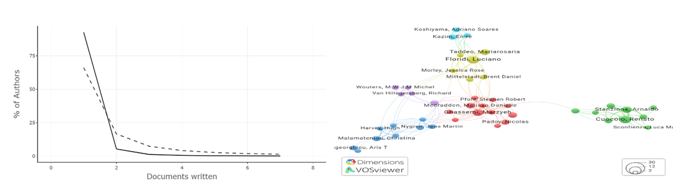

Figure 2 Number of Articles and Documents Figure 1 Cited Authors

**Number of articles**

The trends in publications from 2019 to 2025 show a sharp surge in academic interest in AI applications in auditing and accounting. The initial years had minimal research output, with just three articles in 2019 and two in 2020, showing that the application of AI in financial activities. However, the number of publications grew to 17 in 2021 as people became more aware of the possibilities of AI in financial decision-making and automation. In 2022, there was a sharp increase to 91 articles, and the trend continued to grow in 2023 and 2024 to 149 and 184 publications, respectively. The increase reflects that scientists are moving toward AI-driven auditing, fraud discovery, and risk management of finance, which supports the increasing applicability of AI to financial reporting and regulatory compliance. The reduction in 2025 to a mere 54 publications is quite likely due to missing data and not declining popularity. Overall, the high growth rate in studies on AI and accounting and auditing indicates its growing significance in bringing efficiency, accuracy, and transparency to financial transactions see figure 3.

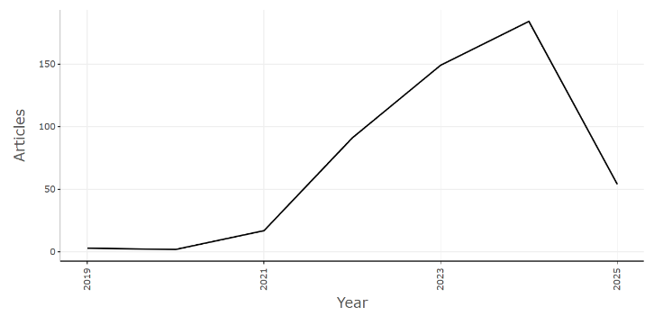

Figure 3 Number of Articles

## **Number of Journals**

The most highly cited include Frontiers in Artificial Intelligence, Journal of Accounting Research, Journal of Financial Technology, Computers in Industry, and International Journal of Auditing. These journals publish high-impact research on AI-based audit systems, machine learning for detecting fraud, and ethical issues of AI-based financial decision-making. All the highest-cited papers appearing in these journals are all related to auditing and risk modeling with AI, algorithms for fraud detection in financial data based on machine learning, and RPA as a vehicle for automation of financial reporting. Some of the most widely debated topics also consist of the moral issues surrounding application of AI in accounting, meeting regulatory demands, and predictive analysis of finance. The citation figures of these papers reveal that these papers have strongly influenced the use of AI in financial processes. The high-impact group in the narrow collection of journals follows Bradford's Law, such that most of the citations within a research domain are provided by a narrow collection of highly cited journals. This finding attests to the prime position of such journals in propagating research on AI in accounting and auditing see figure 4.

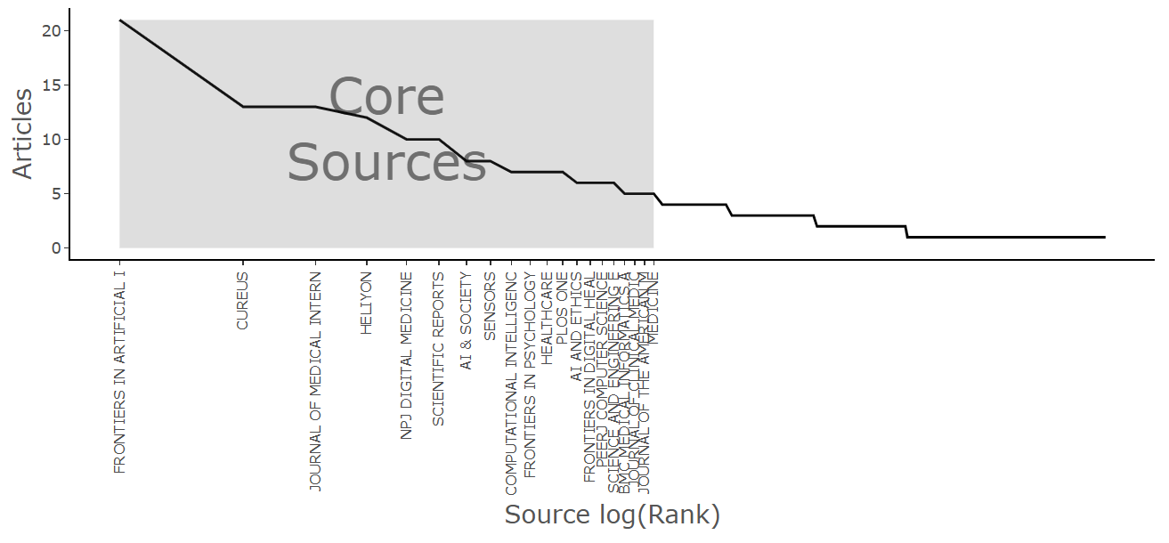

Figure 4 Number of Journals

## **The number of publications per year**

The figure 5 represent the study of the research between 2015 and 2025 indicates an astronomical increase in the number of research studies on AI usage in auditing and accounting, particularly from 2020. The publication was either moderately consistent between 2016 and 2019, varying from 99 to 162 papers per year. However, a significant rise in publications was established in the year 2020, when it increased to 303. The growth trend was continued to later years, with the peak of 882 publications in the year 2024. The sudden surge in research activity reflects an increasing academic interest in AI applications for financial management. The decline in 2025 is due to the half data for the year and not due to declining research activity. The growing emphasis on AI-based accounting and auditing research is also evident in the number of AI-based articles published each year. During the period from 2019 to 2021, AI research activity for this field was low at less than 20 studies being published each year. But it grew exponentially in 2022 with 91 articles, 149 in 2023, and 184 in 2024. This shows that scholars are giving greater importance to AI-driven innovations such as machine learning, robotic process automation (RPA), and natural language processing (NLP) in auditing and accounting practice.

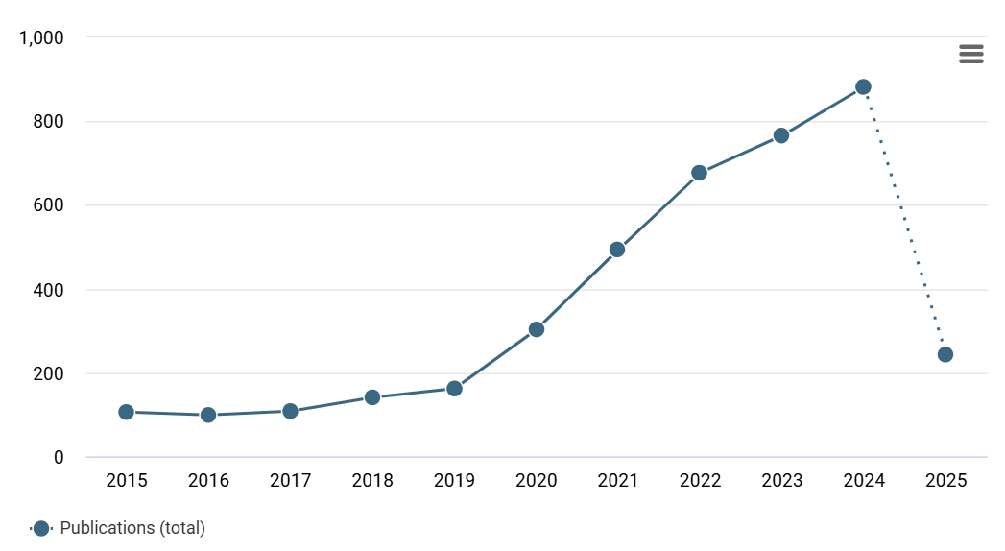

Figure 5 The number of publications per year

## **The countries with the most publications**

Geospatial dispersion of AI-based research on accounting and auditing reflects the United States with the most number of publications at 735. Leadership demonstrates the nation's high level of technology infrastructure, significant investment in AI research, and cooperation between the financial community and universities. The second ranking country is China and it has 322 publications, which demonstrates the nation's heavy investment in AI-based financial technology and automation. Canada is ranked third with 188 publications that indicate the growing interest in using AI for financial risk analysis and fraud detection studies. Germany and Italy are also leading contributors with 144 and 133 publications, respectively, indicating the use of AI for regulatory compliance, audit automation, and financial analysis. The remaining European countries, including the United Kingdom and Spain, also follow with gigantic contributions in the form of 78 and 77 papers, respectively. In other parts of the world outside North America and Europe, there are new research hubs in Ireland, Australia, and the Netherlands with contributions ranging from 50 to 70 papers see figure 6and table 1. Their key areas of research include AI-driven financial reporting, predictive analytics, and AI ethics for auditing. With more than one country playing a remarkable role in this area of study, it implies that AI auditing and accounting is a study of interest at an international level due to the need for automation, accuracy, and transparency in finance.

Table 1 The countries with the most publications

|  |  |
| --- | --- |
| Country | Freq |
| USA | 735 |
| CHINA | 322 |
| CANADA | 188 |
| GERMANY | 144 |
| ITALY | 133 |
| UK | 78 |
| SPAIN | 77 |
| IRELAND | 65 |
| AUSTRALIA | 64 |
| NETHERLANDS | 52 |

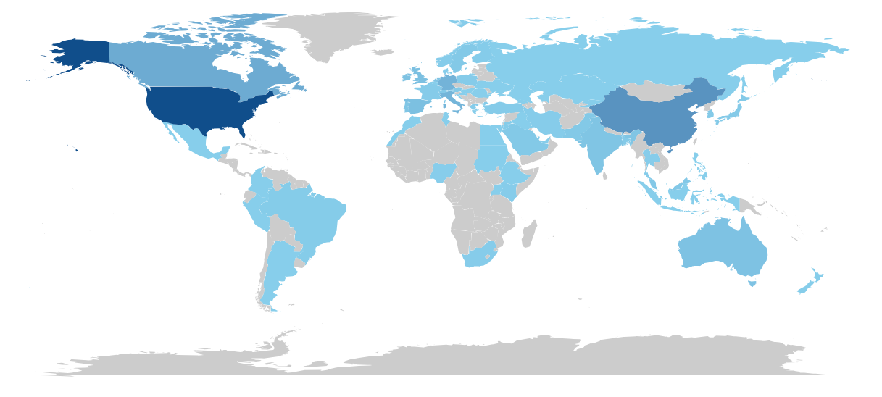

## 

## 

Figure The countries with the most publications

## **Main topics of the articles**

Thematic and keyword trend extraction of research themes identifies some of the most prominent themes in the research area of AI accounting and auditing. Risk assessment and fraud detection is one of the most prominent themes wherein AI models, machine learning models, and anomaly detection tools are widely utilized in identifying suspicious transactions as well as financial irregularities. Robotic accounting audit is the other prevailing topic under which RPA and NLP technologies, amongst others, make it possible for real-time accounting report audit scrutiny with minimum human error and higher regulatory conformity. The majority of studies in this category have studied how AI would enhance auditing quality through the examination of the full dataset instead of the traditional method of sampling. Natural language processing (NLP) financial analysis is another new area, with researchers looking into potential for AI to parse unstructured financial data like earnings releases, contracts, and auditors' reports. NLP is increasingly being applied to automate financial reporting analysis and text sentiment analysis. One of the most prominent areas of application is AI-based predictive analytics and financial forecasting, where machine learning algorithms are employed in revenue forecasting, strategic financial planning, and investment risk analysis. The models provide real-time snapshots of market trends, enabling companies to make data-driven, informed financial decisions. Apart from technological transformation, studies on regulatory and ethical considerations of AI implementation continue. Some of the issues that have been discussed at length in the literature include AI bias, transparency, accountability, and compatibility with accounting reporting guidelines such as GAAP and IFRS. As auditing and accounting become AI-driven, an important research agenda is ensuring that AI-based decision-making systems are fair and unbiased. Real-time AI-based accounting and decision support systems have been another dominant subject. AI-based decision-making applications are equipping firms to support real-time finance tracking, detecting fraud, and financial risk handling. Real-time financial data analytics help organizations to anticipate possible threats and respond beforehand. Thematic research mapping shows that there was early research between the years 2016 and 2019 with the main topic being how AI can automate accounting. More sophisticated areas such as predictive analytics, real-time audit, and AI governance of accounting are the areas of interest from 2020 and beyond see figure 7.

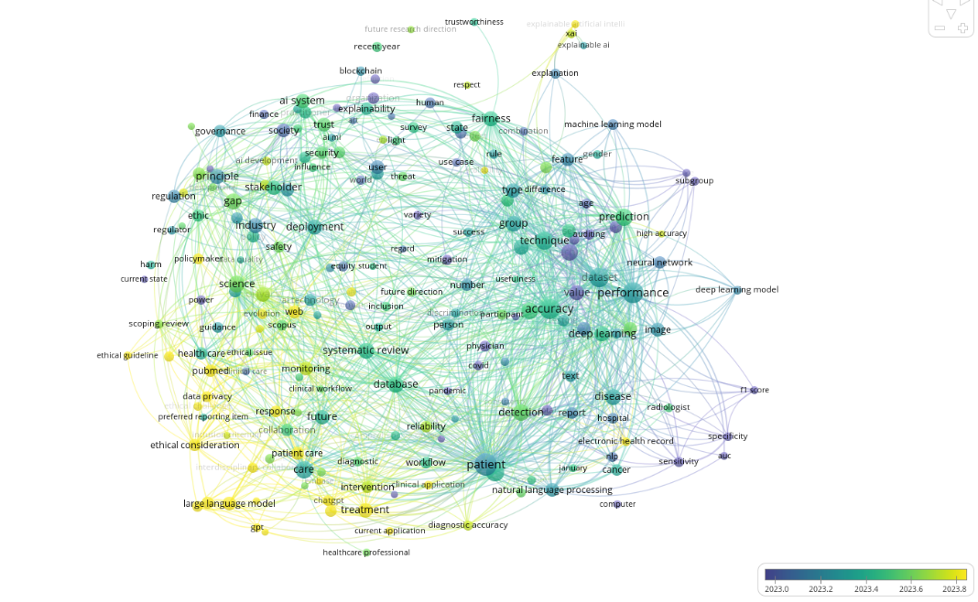

Figure 7 Main topics of the articles

**Discussion**

The findings of this current bibliometric review offer common trends and trends in peer-reviewed literature of applying artificial intelligence (AI) into accounting and auditing. The hitherto unprecedented growth in publications since 2020 offers an increased interest for AI applications into these fields. The number of articles increased from a few in 2019 to 184 in 2024, reflecting an increasing awareness of the potential of AI to enhance efficiency, accuracy, and transparency in financial transactions (Alonge et al., 2024). This reflects the increasing complexity of financial transactions and the resulting need for advanced technological solutions. Risk assessment and fraud detection through AI is one of the most powerful themes that emerged in the literature. Traditional audit processes rely on sampling methodology, which may overlook vital differences in financial data. But with AI tools such as machine learning and robotic process automation (RPA), auditors are now able to verify entire sets of data, providing a better picture of an organization’s financial health (Coovadia & Vorster, 2025). This change increases audit quality and makes a contribution towards the ability to recognize anomalies, even fraud, so financial report overall reliability increases.

The automation proves to be a time and cost saver in order to carry out mundane procedures and allow auditors to use their time in valuable activities such as strategic planning, decision-making, and financial analyses (Lippi & Da Rin, 2019). Adopting AI technology has the potential to have enormous cost advantages for organizations in that it can reduce the need for large human resources in the fulfillment of repetitive audit tasks. Furthermore, the potential to conduct real-time continuous auditing of data enhances the ability of organizations to respond to financial irregularities in a way that they can treat them at the point of occurrence. Despite all of these developments, literature also identifies some regulatory and ethical problems with the use of AI in accounting and auditing. Data privacy is perhaps one of the most prominent problems as financial data is very sensitive and strictly monitored. Use of AI also has other threats in the cybersecurity field because businesses must fend off data breach and misuse of financial data. With growing use of AI in financial accounting, organizations must possess robust security features like encryption and access controls to prevent sensitive data from being compromised. Moreover, adherence to regulatory guidelines like the Generally Accepted Accounting Principles (GAAP) and the International Financial Reporting Standards (IFRS) must be ensured to maintain the integrity of AI-based financial reports (Sreseli, 2023).

The ethical aspects of AI usage in auditing and accounting are also of foremost concern. AI algorithms will be trained on the basis of the training data employed and therefore will not perform to their best if such training data is incomplete, imperfect, or biased in some manner. Therefore, this does bring into question the justice and accountability of resultant AI algorithm decision-making. To address such risks, organizations must make sure that they create open models of AI and establish ethics guidelines to regulate their use in finance management. The government agencies also play a part in defining governance frameworks for AI to regulate its application towards auditing and accounting (De Almeida et al., 2021). Aside from the issue of regulation and ethics, certain research gaps have been identified to exist in literature. While much attention is placed on the technology aspect of AI applications, few in-depth studies have focused on organizational and cultural barriers to the adoption of AI for accounting companies, usually for small and medium-sized enterprises (SMEs). SMEs will mostly not possess the technological ability or funds necessary to implement AI-based systems, which can serve as a barrier to remaining competitive in an ever more technologically sophisticated market. Later studies would have to study the problems that would arise in such organizations and set markers on how exactly they would use AI technologies.

More empirical studies have to be conducted to understand the long-run impact of AI on accounting working functions. Changing to AI-processed processes is going to turn traditional jobs and require new sets of skills, which can lead to staff dislocation (Tapscott, 2024). There needs to be an understanding of how the work of accountants will be affected by AI so that training programs can be developed to equip professionals with the necessary skills to thrive in an AI age. Research also must take into account whether AI can create new professional careers in the field since companies may require experts to deal with and analyze insights generated by AI. Another research subject of the future is examining the effectiveness of AI deployment towards financial reporting and compliance. As additional organizations implement AI to enable financial decision-making, there is an imperative to ascertain the credibility and reliability of the reports produced through AI. Relative effectiveness of AI-generated financial reports compared to traditional methods needs to be investigated through research as well as implications in terms of compliance (Mwachikoka, 2024). This research can provide valuable information about the potential benefits and drawbacks of AI application in financial reporting practice.

# **Conclusion**

This bibliometric overview has presented a detailed exposition of the contemporary trend of knowledge on incorporating artificial intelligence (AI) in auditing and accounting. The outcome exhibits an impressive trend of rising scholarly interest in the subject since the year 2020, reflecting a notable publication peak that links with increasingly heightened awareness about the potential offered by AI in enhancing efficiency, accuracy, and transparency in fiscal operations. Primary issues emerging from literature are automation of audit processes, risk assessment, and fraud identification, all signaling the revolutionary impacts of AI technologies such as machine learning, RPA, and NLP on traditional accounting practices. Even while progressing with the review, there have been issues of ethics and regulation in the use of AI in auditing and accounting identified. These challenges like data privacy, algorithm bias, and meeting required accounting standards require solving such issues to employ AI appropriately. In addition, the research reflected important research gaps, especially for organizational and cultural resistance to adopting AI, lasting effect on professional work tasks in the field, and effectiveness of AI to facilitate financial reporting and compliance.

In order to provide a better focus for future studies on this emerging issue, the following are proposed:

* Organizational Barriers Research: Future studies must investigate the distinct barriers to AI technology uptake by small and medium-sized businesses (SMEs). It can then subsequently lead to designing AI implementation plans for different organizational contexts.
* Longitudinal Workforce Impact Studies conducted: Empirical studies need to be conducted to ascertain the long-term effect of AI on accounting work tasks. The studies need to ascertain new skill requirements and possible job displacement and AI field job creation possibilities.
* Interdisciplinary Research: Interdisciplinary research through the integration of accounting, information technology, and ethics experts is required. This interdisciplinary approach can create more integrated solutions with focus on the technical and ethical implications of using AI in financial management.
* Evaluation of AI Performance: Future research needs to address comparative performance of AI-based financial reporting in relation to traditional practices. Research needs to test the reliability and replicability of AI-based reports and regulatory compliance issues related to them.
* World Insights into AI Adoption: With the ongoing development of AI technologies, there is a necessity to study how they can be efficiently applied in various economic climates, especially with emphasis in the emerging economies. Research must map support systems necessary to aid the adoption of AI in such economies.
* Creation of Ethical Framework: There needs to be study in order to develop ethical criteria and governance models for AI for auditing and accounting. Study ought to cross transparence, accountableness, and reasonableness of the AI determination-making process.

The application of AI to accounting and auditing is an opportunity and a challenge. As the profession demonstrations forward into the future, it will be critical that research navigate the tightrope between the challenges of applying AI and upholding ethics and professional duty. Through addressing the research needs uncovered and through encouraging collaboration among stakeholders, the accountancy profession can harness the full potential of AI technologies and, in turn, enhance the quality and integrity of financial reports.

**References**

Abdullah, A. A. H., & Almaqtari, F. A. (2024). The impact of artificial intelligence and Industry 4.0 on transforming accounting and auditing practices. *Journal of Open Innovation: Technology, Market, and Complexity*, *10*(1), 100218.

Al-Obaidy, F. H. (2024). Developing an Accounting Information System Based on Artificial Intelligence to Improve the Quality of Accounting Information and the Decision-Making Process. *Academia Open*, *9*(2), 10-21070.

Alonge, E. O., Dudu, O. F., & Alao, O. B. (2024). The impact of digital transformation on financial reporting and accountability in emerging markets. *International Journal of Science and Technology Research Archive*, *7*(2), 025-049.

Anomah, S., Ayeboafo, B., Owusu, A., & Aduamoah, M. (2024). Adapting to AI: exploring the implications of AI integration in shaping the accounting and auditing profession for developing economies. *EDPACS*, *69*(11), 28-52.

Bargh, M. S., & Choenni, S. (2019, December). Towards applying design-thinking for designing privacy-protecting information systems. In *2019 First IEEE International Conference on Trust, Privacy and Security in Intelligent Systems and Applications (TPS-ISA)* (pp. 196-202). IEEE.

Barišić, I. (2022, June). Ethical principles and the implementation of artificial intelligence in accounting and auditing practice. In *Proceedings of FEB Zagreb International Odyssey Conference on Economics and Business* (Vol. 4, No. 1, pp. 2-14). University of Zagreb, Faculty of Economics and Business.

Büyükkıdık, S. (2022). A bibliometric analysis: A tutorial for the bibliometrix package in R using IRT literature. *Journal of Measurement and Evaluation in Education and Psychology*, *13*(3), 164-193.

Cai, Y., Ramis Ferrer, B., & Luis Martinez Lastra, J. (2019). Building university-industry co-innovation networks in transnational innovation ecosystems: Towards a transdisciplinary approach of integrating social sciences and artificial intelligence. *Sustainability*, *11*(17), 4633.

Coovadia, H., & Vorster, S. (2025). Does Robotic Process Automation (RPA) implementation create value in organisational processes and, more specifically, in internal audit (IA) functions?. *African Journal of Innovation & Entrepreneurship (AJIE)*, *4*(1).

De Almeida, P. G. R., dos Santos, C. D., & Farias, J. S. (2021). Artificial intelligence regulation: a framework for governance. *Ethics and Information Technology*, *23*(3), 505-525.

Francisco, L. M. C. (2024). The Impact of Emerging Technologies in Accounting and Auditing.

Hallinger, P., & Kovačević, J. (2019). A bibliometric review of research on educational administration: Science mapping the literature, 1960 to 2018. *Review of Educational Research*, *89*(3), 335-369.

Harju, J. (2023). Changes in the Adoption of AI Technologies into Accounting.

Hasan, A. R. (2021). Artificial Intelligence (AI) in accounting & auditing: A Literature review. *Open Journal of Business and Management*, *10*(1), 440-465.

Hasan, A. R. (2021). Artificial Intelligence (AI) in accounting & auditing: A Literature review. *Open Journal of Business and Management*, *10*(1), 440-465.

Jin, B. E., & Shin, D. C. (2021). The power of 4th industrial revolution in the fashion industry: what, why, and how has the industry changed?. *Fashion and Textiles*, *8*(1), 31.

Lee, I., & Shin, Y. J. (2020). Machine learning for enterprises: Applications, algorithm selection, and challenges. *Business Horizons*, *63*(2), 157-170.

Lippi, G., & Da Rin, G. (2019). Advantages and limitations of total laboratory automation: a personal overview. *Clinical Chemistry and Laboratory Medicine (CCLM)*, *57*(6), 802-811.

Mwachikoka, C. F. (2024). Effects of artificial intelligence on financial reporting accuracy. *World Journal of Advanced Research and Reviews*, *23*(3), 1751-1767.

Naveed, R. T., Alhaidan, H., Al Halbusi, H., & Al-Swidi, A. K. (2022). Do organizations really evolve? The critical link between organizational culture and organizational innovation toward organizational effectiveness: Pivotal role of organizational resistance. *Journal of Innovation & Knowledge*, *7*(2), 100178.

Oyeniyi, L. D., Ugochukwu, C. E., & Mhlongo, N. Z. (2024). Robotic process automation in routine accounting tasks: A review and efficiency analysis. *World Journal of Advanced Research and Reviews*, *22*(1), 695-711.

Sreseli, N. (2023). Use of Artificial Intelligence for Accounting and Financial Reporting Purposes: A Review of the Key Issues. *American International Journal of Business Management (AIJBM)*, *6*(8), 72-83.

Stoykova, A. (2024). AI in Accounting: Insights from a Bibliometric Analysis. *CECCAR Business Review*, *5*(8), 56-71.

Tapscott, B. (2024). *Trivergence: Accelerating Innovation with AI, Blockchain, and the Internet of Things*. John Wiley & Sons.

Usul, H., & Alpay, M. F. (2024). From Traditional Auditing to Information Technology Auditing: A Paradigm Shift in Practices. *European Journal of Digital Economy Research*, *5*(1), 3-9.

Yang, J., Amrollahi, A., & Marrone, M. (2024). Harnessing the potential of artificial intelligence: affordances, constraints, and strategic implications for professional services. *The Journal of Strategic Information Systems*, *33*(4), 101864.